Rainfall Rate Detector

Description:
The Rainfall Rate Detector is a simple electronics project that detects the intensity of rainfall using a rain drop sensor. The system indicates the rainfall level using three LEDs. When there is no rain, the green LED glows. During moderate rain, the yellow LED glows, and during heavy rainfall, the red LED glows. This project helps in understanding rain detection and visual indication using sensors and LEDs.
Block Diagram:
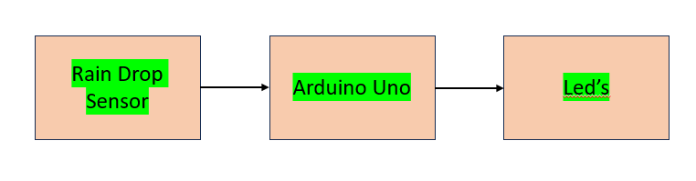
Pinout / Circuit Connection:
Rain Sensor → Arduino
Rain Sensor Pin | Arduino
VCC | 5V
GND | GND
AO | A0
LED Connections
LED | Arduino Pin
Green LED | D8
Yellow LED | D9
Red LED | D10
Each LED positive → 220Ω resistor → Arduino pin
Each LED negative → GND
Components Required:
- Arduino UNO
- Rain Drop Sensor Module
- Green LED
- Yellow LED
- Red LED
- 3 × 220Ω Resistors
- Breadboard
- Jumper wires
Working Principle:
The rain drop sensor detects water droplets on its surface. When rain falls on the sensor plate, its resistance changes, which results in a change in the analog output voltage. Arduino reads this analog value and determines the rainfall intensity. Based on the sensor value, Arduino activates the appropriate LED indicator.
Typical values:
- No rain → sensor value near 1023
- Moderate rain → medium sensor value
- Heavy rain → low sensor value
Operation (Step-by-Step):
- Power ON the Arduino system.
- The rain sensor continuously monitors the presence of water droplets.
- Arduino reads the analog value from the rain sensor.
- If no rain is detected, the green LED glows.
- If moderate rain occurs, the yellow LED glows.
- If heavy rainfall occurs, the red LED glows.
Arduino Code:
int rainSensor = A0;

int greenLED = 8;
int yellowLED = 9;
int redLED = 10;

void setup() {
Serial.begin(9600);

pinMode(greenLED, OUTPUT);
pinMode(yellowLED, OUTPUT);
pinMode(redLED, OUTPUT);
}

void loop() {

int rainValue = analogRead(rainSensor);

Serial.print("Rain Value: ");
Serial.println(rainValue);

if (rainValue >= 950) { // No rain
digitalWrite(greenLED, HIGH);
digitalWrite(yellowLED, LOW);
digitalWrite(redLED, LOW);
}

else if (rainValue >= 600 && rainValue < 950) { // Moderate rain
digitalWrite(greenLED, LOW);
digitalWrite(yellowLED, HIGH);
digitalWrite(redLED, LOW);
}

else { // Heavy rain
digitalWrite(greenLED, LOW);
digitalWrite(yellowLED, LOW);
digitalWrite(redLED, HIGH);
}

delay(500);
}
Conclusion:
The Rainfall Rate Detector is a simple and effective system to monitor rainfall intensity using LED indicators. It demonstrates the practical use of sensors and microcontrollers in environmental monitoring systems.
References:
- Arduino Project Hub – Rain Sensor Module Tutorial
- Electronics Tutorials – Rain Detection Circuits

